Lewknor Church of England Primary School
English Two-Year Cycle



Lewknor Primary School’s Two-Year Cycle - English
Lower Juniors
Cycle A
Autumn 1 | Autumn 2 | Spring 1 | Spring 2 | Summer 1 | Summer 2
Magic and mystery | Dreams & desires | Hope & healing | Overcoming adversity | From mystery to discovery | Pride & downfall
Nen and the Lonely Fisherman  Ian Eagleton | The BFG Roald Dahl | Frindleswylde  Natalia & Lauren O’Hara | The Lion and the Unicorn Shirley Hughes | The Thames and Tide Club Katya Balen | Our Tower  Joseph Coelho
The Heart and the Bottle Oliver Jeffers | The Barnabus Project  The Fan Brothers | Escape from Pompeii  Christina Balit | Sparky  Jenny Offil | How to Live Forever  Colin Thompson | FArTHER  Grahame Baker Smith
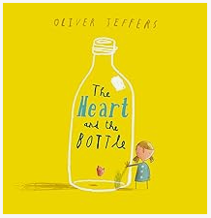  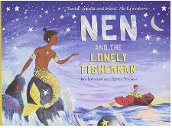  Book | Book  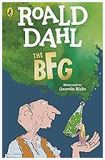  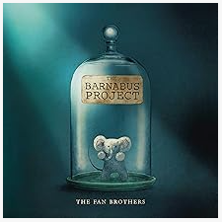 | Book  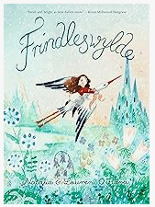  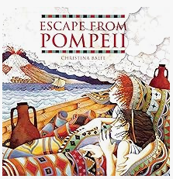 | Book  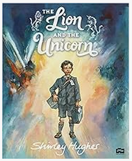  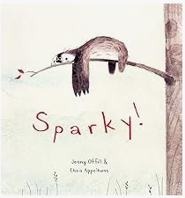 | Book  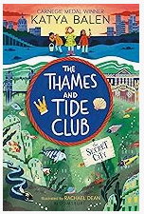  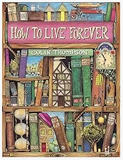 | Book  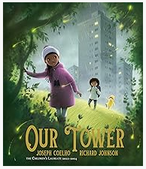  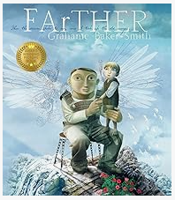
Weeks  15 sessions, 3 weeks | Weeks  15 sessions, 3 weeks | Weeks  15 sessions, 3 weeks | Weeks  15 sessions, 3 weeks | Weeks  15 sessions, 3 weeks | Weeks  15 sessions, 3 weeks
Outcomes/Main outcome(s) in red  Nen and the Lonely Fisherman: Lonely hearts advert character description, thought bubbles, diary entries, message in a bottle setting description, own version of the narrative with a twist on the traditional tale  The Heart and the Bottle: Dialogue, postcard, character description, diary entry, poetry, letter of advice, own version ‘dilemma’ narrative | Outcomes/Main outcome(s) in red  The BFG:  Recount (diary entry), character descriptions, wanted posters, new chapter, instructions (recipes), letters, own version narrative (fantasy)  The Barnabus Project:  Instructional writing (escape plan, experiment), descriptions, advertisements, letters of advice, dialogue, brochure | Outcomes/Main outcome(s) in red  Frindleswylde:  Letters, voting slips, dialogue, poetry, birds-eye view descriptions, persuasive speeches, narrative sequel  Escape from Pompeii:  Setting descriptions, diaries, letters, thought bubbles, newspaper report | Outcomes/Main outcome(s) in red  The Lion and the Unicorn:  Letters, diary entries, character and setting descriptions, non-chronological reports, historical narrative  R Sparky:  Descriptive passage, ‘how to’ guide, letter, discussion, non-chronological report, own version narrative about an unusual friendship | Outcomes/Main outcome(s) in red  The Thames and Tide Club:  Persuasive letters and letters of advice, diary entry, weather report, advertisement, dialogue, own version fantasy narrative  How to Live Forever:  Lost posters, dialogue, setting and character descriptions, ledger entries, instructions, letters of warning, Prequel | Outcomes/Main outcome(s) in red  Our Tower:  Poems, setting descriptions, diary entries, dialogue, letters of thanks, extended fantasy narrative  FArTHER:  Retellings, recounts (postcards), setting descriptions, diary entries, instructions, sequel story

Lewknor Primary School’s Two-Year Cycle - English
Lower Juniors
Cycle B
Autumn 1 | Autumn 2 | Spring 1 | Spring 2 | Summer 1 | Summer 2
Imagination & freedom | Invention & transformation | Finding your future | Taking courage | Unearthing civilisations | Fantasy worlds
The Matchbox Diary  Paul Fleischman | The Tin Forest  Helen Ward | The Pied Piper of Hamelin Michael Morpurgo | Black Dog  Levi Pinfold | Weslandia  Paul Fleischman | The Lion the Witch and the Wardrobe  C. S. Lewis
Varmints  Helen Ward | The Iron Man  Ted Hughes | The Selfish Giant  Oscar Wilde | The Wilderness  Steve McCarthy | Flotsam  David Wiesner | The Zebra’s Great Escape Katherine Rundell
Book  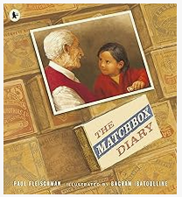  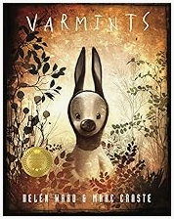 | Book  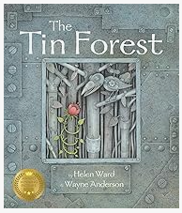  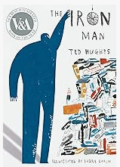 | Book  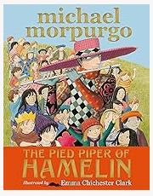  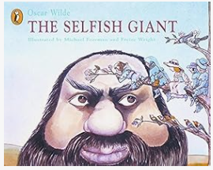 | Book  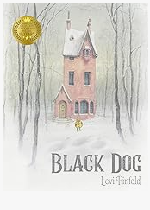  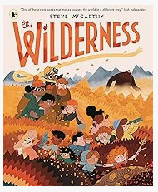 | Book  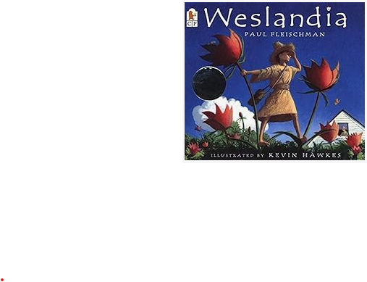  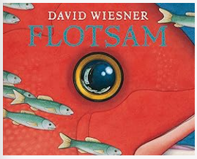 | Book  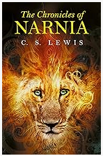  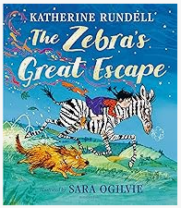
Weeks  15 sessions, 3 weeks  16 sessions, 3+ weeks | Weeks  15 sessions, 3 weeks  18 sessions, 3+ weeks | Weeks  15 sessions, 3 weeks | Weeks  15 sessions, 3 weeks | Weeks  15 sessions, 3 weeks | Weeks  20 sessions, 4 weeks  12 sessions, 2+ weeks
Outcomes/Main outcome(s) in red  The Matchbox Diary:  Dialogue, diary entry, re-telling (oral dictation), mini-autobiography, fact file, biography  Varmints:  Diary entry, instructions, letter, description, speech, explanation of a life cycle | Outcomes/Main outcome(s) in red  The Tin Forest:  Persuasive posters, information leaflets, postcards, diary entries, wishes, setting descriptions, Persuasive information leaflet  The Iron Man:  Character description, short news bulletin, letter of advice, diary entry, menu, logbook entry, mystery narrative | Outcomes/Main outcome(s) in red  The Pied Piper of Hamelin:  Writing in role, information reports, adverts, formal letters, own version myth/legend  The Selfish Giant:  Letters, first person recount, diaries, letters, posters, reports, own version narrative about kindness | Outcomes/Main outcome(s) in red  Black dog:  Postcard, dialogue, retelling, description, own version ‘suspense’ narrative  The Wilderness:  a ‘meet the family’ character introduction; letter of advice; descriptive poem; SOS message; identification label. a guide to enjoying the wilderness | Outcomes/Main outcome(s) in red  Weslandia:  Retelling, character description, book review, non-chronological report  Flotsum:  Postcards, setting descriptions, non- chronological reports, message in a bottle letters, sequel (mystery narrative) | Outcomes/Main outcome(s) in red  The Lion the Witch and the Wardrobe:  Poem, eyewitness report, an imaginary conversation, writing in role, own version narrative set in another world  The Zebra’s Great Escape:  Thought bubbles, missing scenes, diaries, own version narratives

