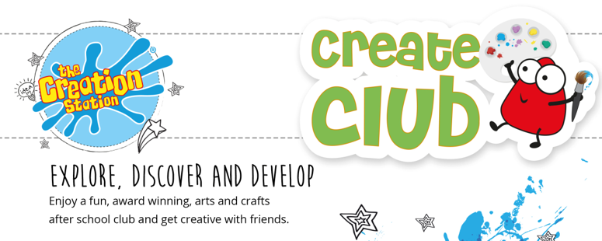

The Creation Station Art Club
Is at Lewknor C of E Primary School!

A creative haven for your child to be inspired to paint, sculpt, collage, sketch and much more…giving you more time to get on with what you have to do and without the hassle of having to clear up any of the mess!
Classes will be held each Monday 3:20 - 4:20pm from June 3rd 2024. The cost of each session is £7.50 and you can book a block online via:
https://portal.thecreationstation.franscape.io/class-overview/6490

Staff will take children straight from their classroom to our club at school held in the school hall.
This term is called "The Art of Science". Each week your child will be involved in a wide range of fun art and crafts activities planting and discovering a wide variety of materials and techniques for maximum fun and learning!
A welcome email will be sent out once you have booked with the practical details, but if you have any questions or wish to book a single, trial class (chargeable at the same rate subject to space) please do get in touch at

emmawinterbourne@thecreationstation.co.uk

